Controller Design Best Practices & [ DTO vs Entity ]

Controller Design Best Practices
What is a Controller?
A Controller in Spring Boot is the entry point of your application.
It handles:
- Incoming HTTP requests
- Delegates work to service layer
- Returns response to client
It should NOT contain business logic
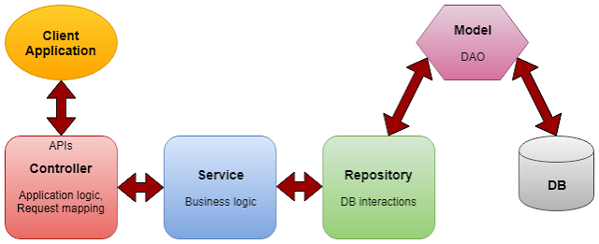

❗ Common Mistakes
❌ Writing business logic inside controller
❌ Direct DB calls from controller
❌ Returning entities directly

✅ Ideal Responsibility of Controller
✔ Accept request (path, params, body)
✔ Validate input
✔ Call service layer
✔ Return proper response (status + body)
Best Practices (Production Level)

1. Keep Controller Thin
❌ Bad Controller = Routing layer, NOT logic layer
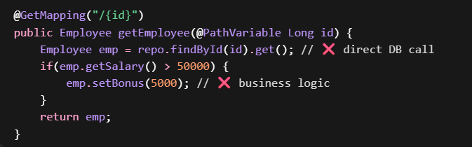
✅ Good:
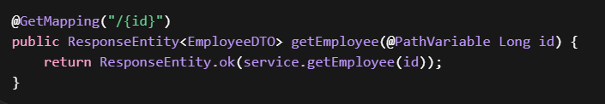

2. Use Proper HTTP Status Codes
1. CREATE API (POST)
Worst Practice:
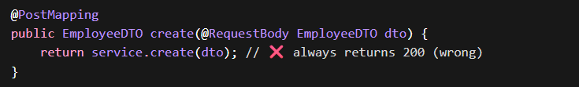 Creation should return 201 CREATED
Best Practice:
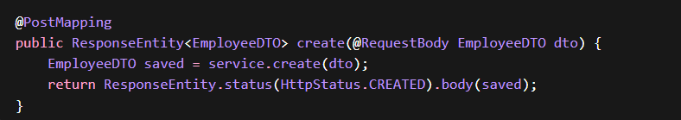
2. GET API (Single Resource)
Worst Practice
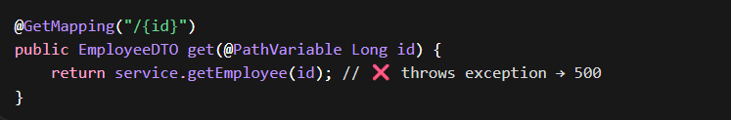
Best Practice
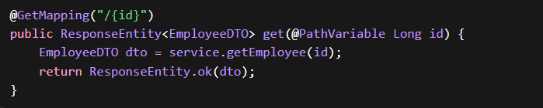
⭐ Better with Optional Handling
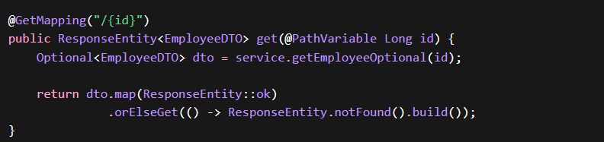

3. GET ALL API
Worst Practice
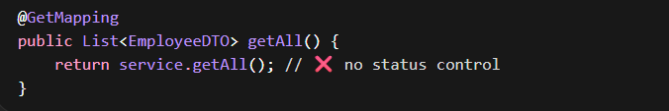
Best Practice
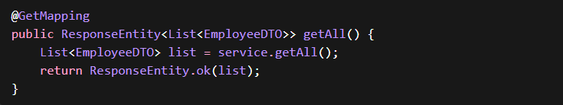
⭐ Advanced (Empty List Handling)
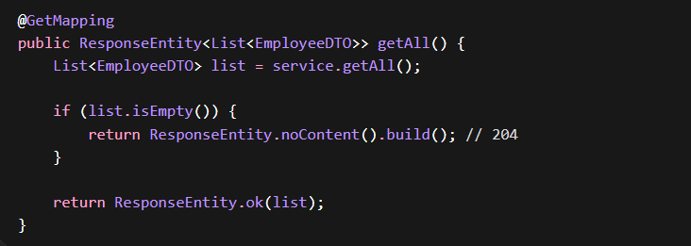
4. UPDATE API (PUT)
Worst Practice
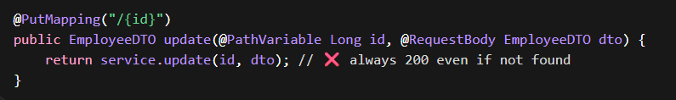
Best Practice
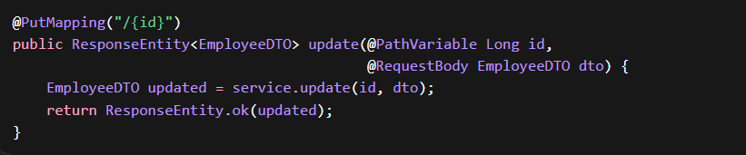
⭐ Better with Validation
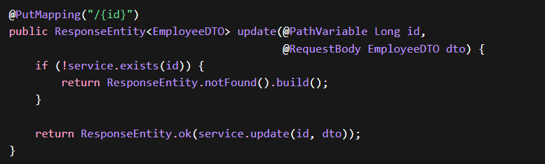

5. DELETE API
Worst Practice
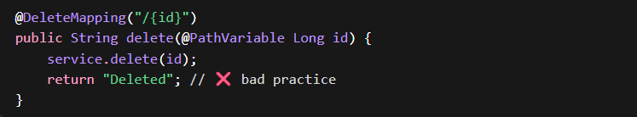
Best Practice
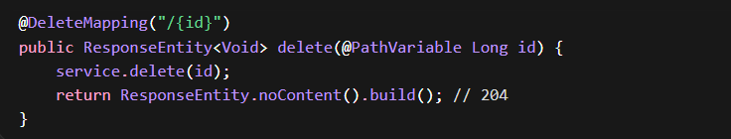

3.Use @RequestMapping Properly
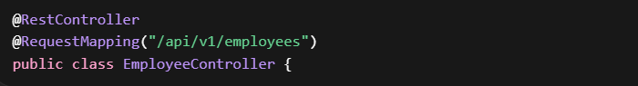
✔ Versioning
✔ Clean URL structure

4.Validate Inputs
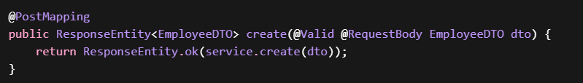👉 Add validations in DTO:


5. Use DTOs (Not Entities)
Using DTOs Instead of Entities in Controller
WRONG Approach (Using Entity Directly in Controller)
🔴 Entity
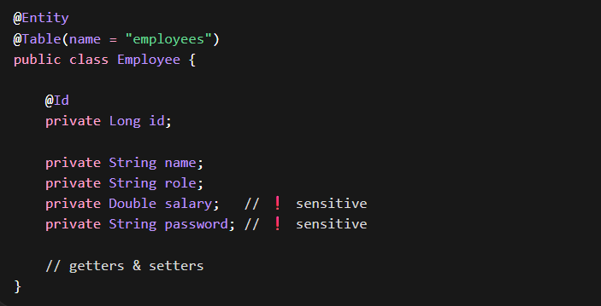
🔴 Controller (BAD PRACTICE)
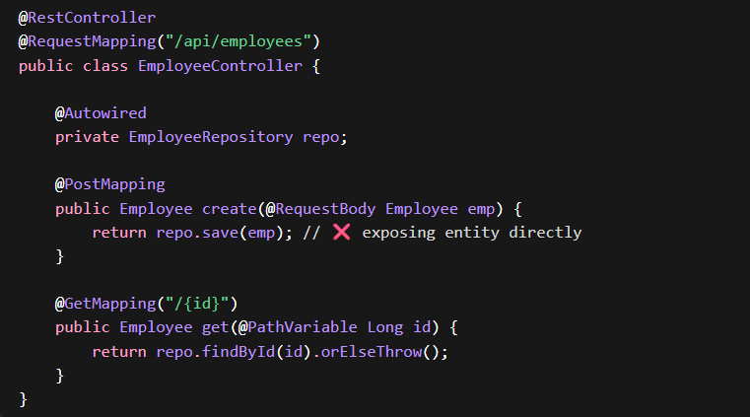
Problems
- Exposes sensitive data (salary, password)
- Tight coupling with DB structure
- No control over API response
- Breaks when entity changes

CORRECT Approach (Using DTO)
Step 1: Entity (Internal Use Only)
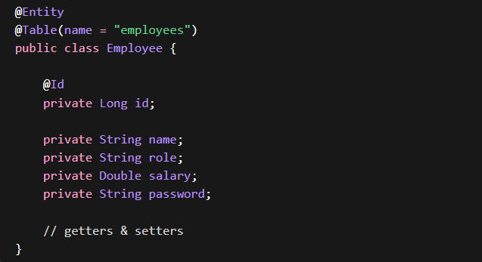
Step 2: DTO (What API exposes)
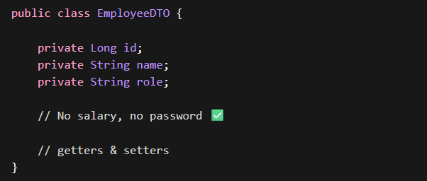

Step 3: Service Layer (Mapping)
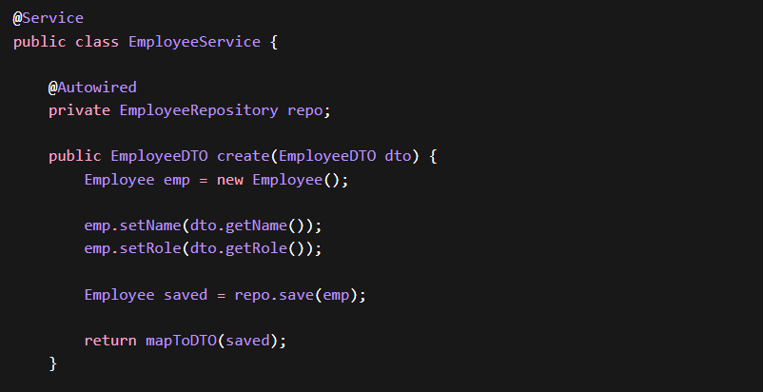
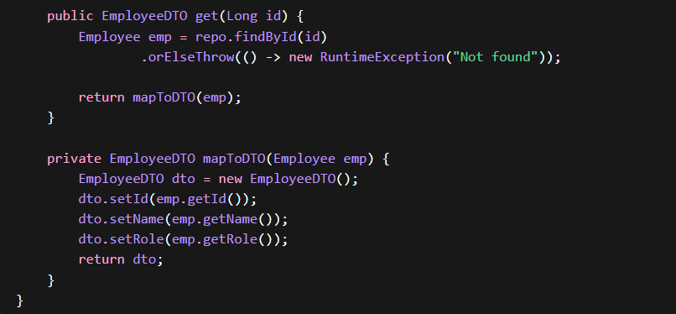

Step 4: Controller (Clean & Safe)
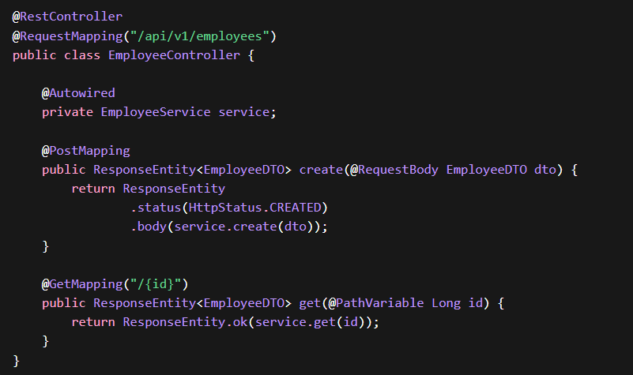
Full Flow
- Client → Controller → DTO → Service → Entity → DB
- DB → Entity → Service → DTO → Controller → Client
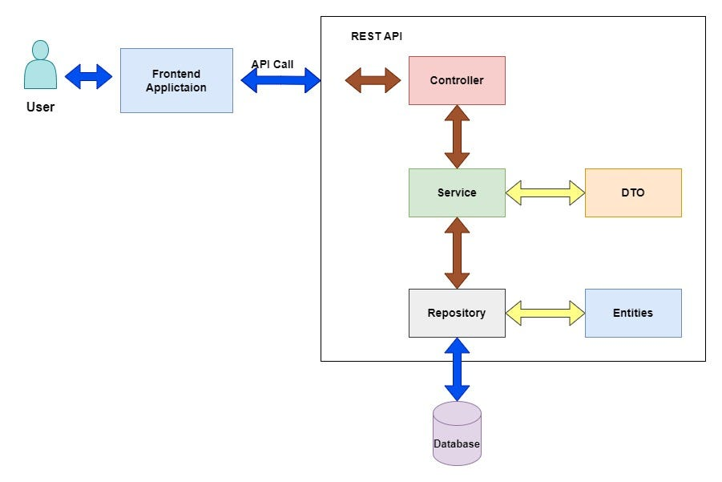
“Entities are for database, DTOs are for API — never mix both.”
6. Handle Exceptions Globally
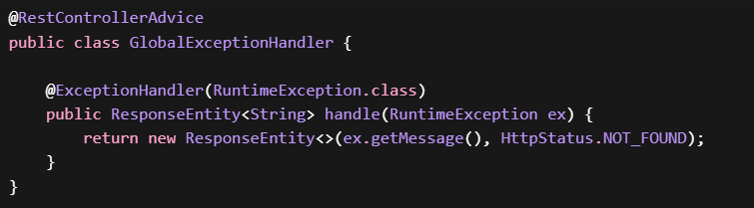
7. Consistent Response Structure (Advanced)
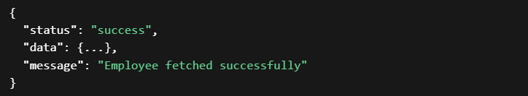
Clean Controller Example
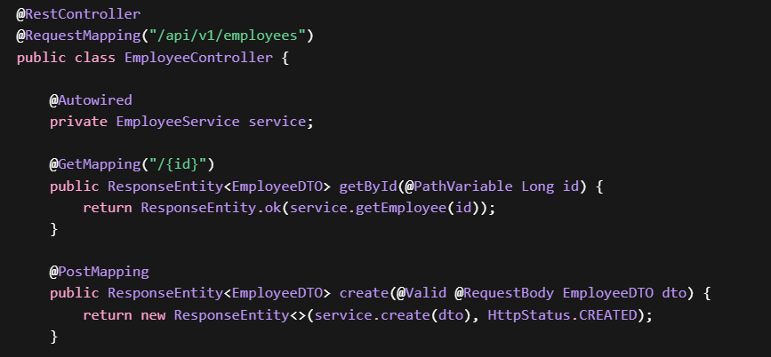
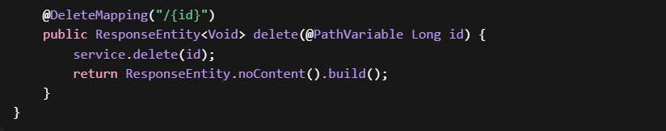

DTO vs Entity
What is an Entity?
An Entity represents a database table.
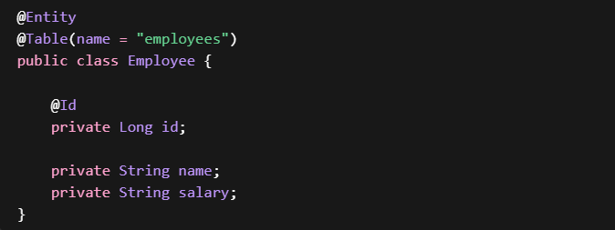Directly mapped to DB
What is a DTO?
A DTO (Data Transfer Object) is used to transfer data between layers (or to client).
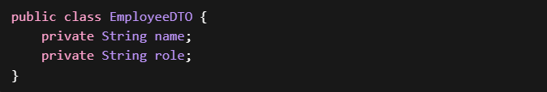Not linked to DB

“We use DTOs to control what data is exposed to the client.
Entities are tightly coupled with the database and may contain sen sitive fields.
So we map Entity to DTO in the service layer and return DTO from controllers.”

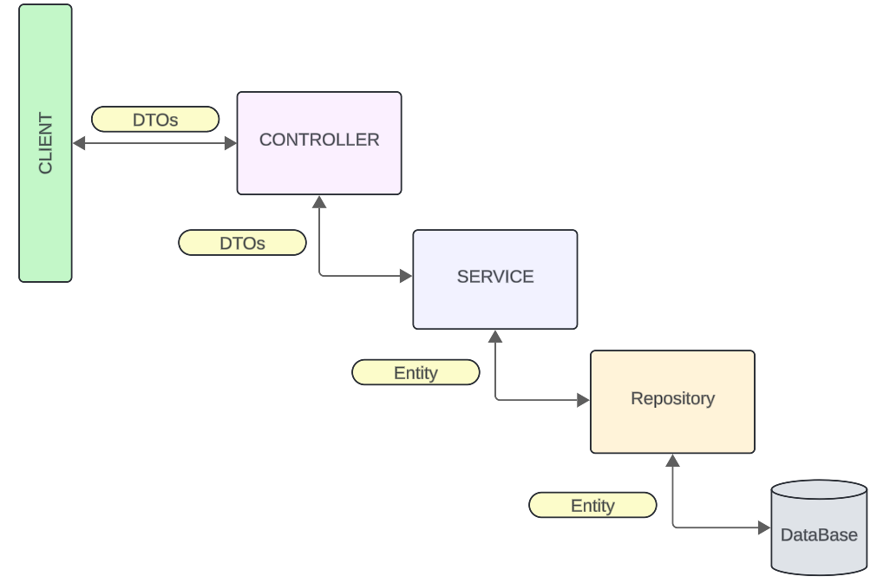
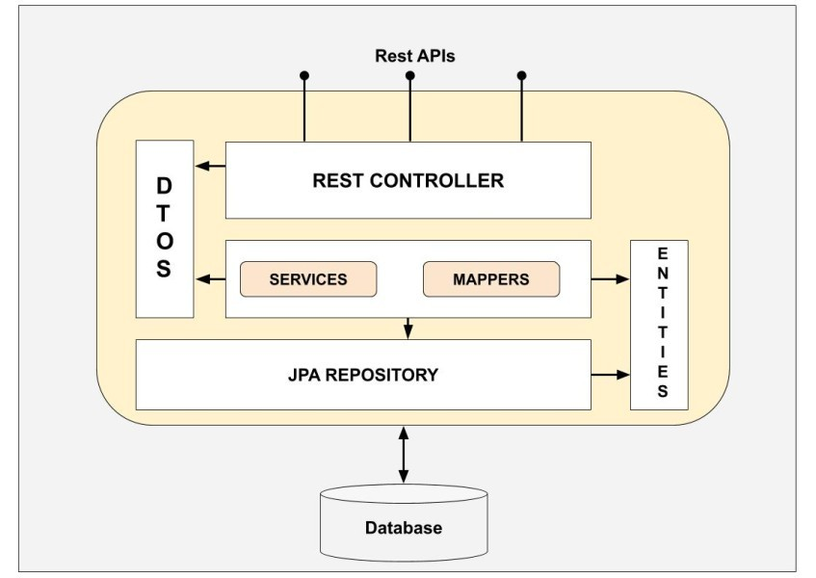

Why NOT Return Entity Directly?
1. Security Issue
Entity may contain sensitive fields:
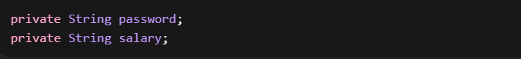
2. Tight Coupling
If DB structure changes → API breaks
3. Over-fetching Data
Client gets unnecessary fields
DTO Advantages
✔ Controls exposed data
✔ Improves security
✔ Decouples DB from API
✔ Supports multiple views (Admin/User)

Entity vs DTO (Interview Table)
Feature | Entity | DTO
Purpose | DB mapping | Data transfer
Annotation | @Entity | Plain class
Exposure | Internal | External
Security | Risky | Safe
Flexibility | Low | High

Mapping: Entity ↔ DTO
Manual Mapping
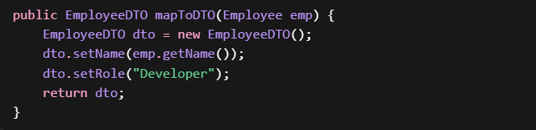
Using Mapper (Recommended for Projects)
- MapStruct
- ModelMapper

Service Layer Using DTO
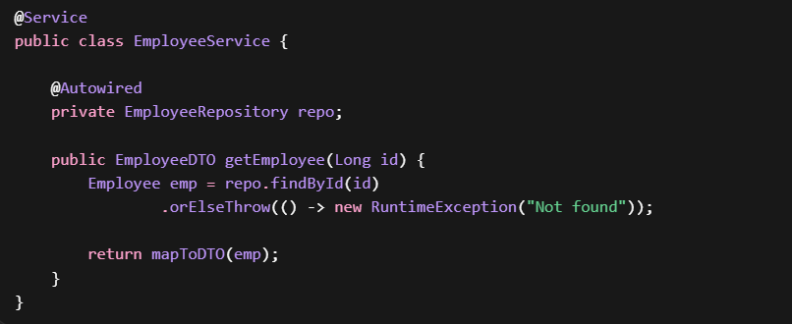
“Clean backend design = Thin controllers + DTO-based communication + layered architecture.”

PART 1: Controller Design – Interview Questions & Answers

1. What is the role of a Controller in Spring Boot?
A Controller is responsible for:
- Handling incoming HTTP requests
- Mapping requests to endpoints
- Delegating business logic to the Service layer
- Returning appropriate HTTP responses
It acts as a bridge between client and backend logic
Controller should be thin and should NOT contain business logic.

2. Why should controllers be “thin”?
Controllers should be thin to maintain:
- Separation of concerns
- Clean architecture
- Testability
If controllers contain business logic:
- Code becomes hard to maintain
- Logic gets duplicated
- Testing becomes difficult

❌ Bad:
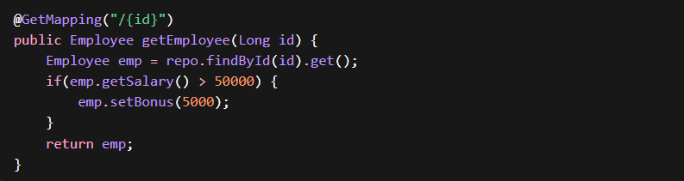
✅ Good:
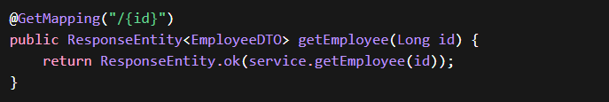
3. Can we write business logic in Controller?
Technically yes, but not recommended
Controllers should only:
- Handle request/response
- Call service layer
All business logic must be in the Service layer

4. What is ResponseEntity and why do we use it?
ResponseEntity represents the entire HTTP response, including:
- Status code
- Headers
- Body
It gives full control over response

5. How do you handle exceptions in Spring Boot?
Using Global Exception Handling with @RestControllerAdvice
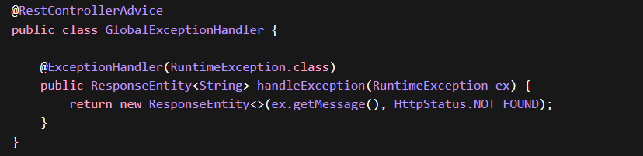
Avoid handling exceptions inside controllers
6. What is API versioning and why is it important?
API versioning allows maintaining multiple versions of APIs.
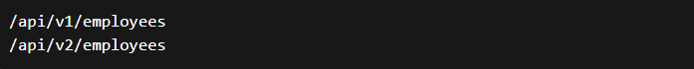Helps in:
- Backward compatibility
- Smooth upgrades

7. How do you validate request data in Controller?
Using @Valid and validation annotations
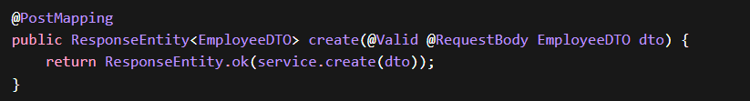

8. What are best practices for designing REST endpoints?
- Use nouns, not verbs → /employees
- Use proper HTTP methods
- Keep URLs clean and consistent
- Use plural resource names

9. What is the difference between @Controller and @RestController?
Annotation | Purpose
@Controller | Returns views (HTML)
@RestController | Returns JSON (REST APIs)

10. How do you design a production-ready controller?
- Thin controller
- Use DTOs
- Proper status codes
- Validation
- Exception handling
- Versioning

PART 2: DTO vs Entity – Interview Questions & Answers

11. What is an Entity?
An Entity is a class mapped to a database table using JPA.
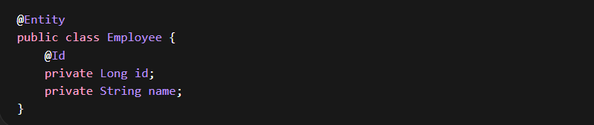
12. What is a DTO?
A DTO (Data Transfer Object) is used to transfer data between layers or to the client.
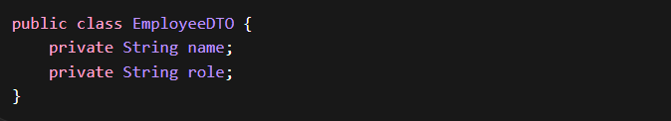

13. What is the difference between DTO and Entity?
Feature | Entity | DTO
Purpose | DB mapping | Data transfer
Annotation | @Entity | No annotation
Exposure | Internal | External
Security | Risky | Safe

14. Why should we not expose Entity directly?
- Security issues (sensitive fields exposed)
- Tight coupling with DB
- Over-fetching data
- Difficult to modify API without DB changes

15. What problems does DTO solve?
- Data hiding
- Flexible API design
- Multiple views (Admin/User)
- Reduces unnecessary data transfer

16. How do you convert Entity to DTO?
Manual Mapping:
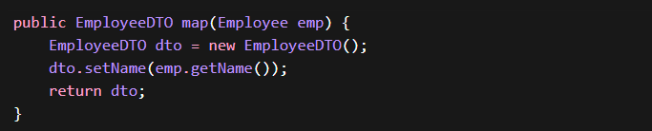
Using Libraries:
- MapStruct
- ModelMapper
17. Where should mapping logic be written?
- Service layer
- Or separate Mapper class
Not inside Controller

18. Can DTO and Entity have same fields?
Yes, but they should still be separate classes.
Future flexibility is the reason
19. What is Request DTO vs Response DTO?
Type | Purpose
Request DTO | Input from client
Response DTO | Output to client
Helps in better control

20. What happens if we don’t use DTO?
- Security risks
- Poor API design
- Tight coupling
- Hard to scale application

“In Spring Boot, we design controllers as thin layers that only handle HTTP requests and delegate logic to services.
We use DTOs to ensure clean separation between API and database layers, improving security and flexibility.
We also follow best practices like validation, proper status codes, and global exception handling to build production-ready APIs.”

